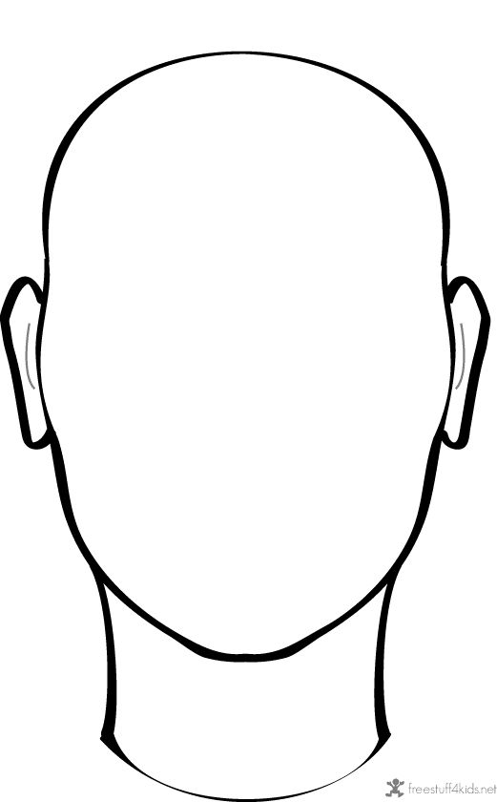

Draw or write words to share how you feel on the inside, and how people see you on the outside.

You might want to explore how you look or feel at different times or places in the day eg at home, school or out with friends.

How I feel on the inside

What people see on the outside