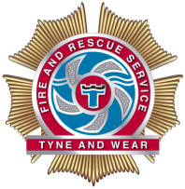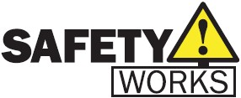

SafetyWorks! is an interactive safety centre run by Tyne and Wear Fire and Rescue Service. We offer safety sessions to schools and youth groups, including groups of home educated children.

The sessions are 1.5-2 hours long, and would include talks such as fire safety, water safety, travel safety and more (These may vary depending on facilitators availability). Sessions cost £105. Children attending the session would need to be split into groups of key stages, as messages differ for different age groups. For more information, visit our website at [www.safetyworks.org.uk](http://www.safetyworks.org.uk)

If you would be interested in booking, please contact us on 0191 444 1130 or email us at [safetyworks@twfire.gov.uk](mailto:safetyworks@twfire.gov.uk)

**Please note, these sessions are not aimed at individual families, we can take a minimum of 15 children and a maximum of 40**