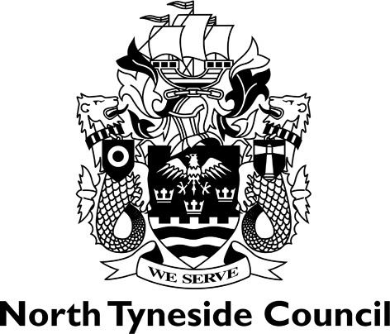

REGISTER OF CARAVAN SITES

October 2018

Site Name | Address | Licence Holder | Site Category | Number of  caravans
Whitley Bay Holiday Park | Blyth Road, Whitley Bay, NE26 4RR | Park Resorts Ltd  2nd floor  One Gosforth Park Way  Gosforth Business Park  Newcastle upon Tyne  NE12 8ET | Static - Holiday | 552

